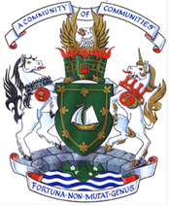
PROCLAMATION

Melanoma and Skin Care Awareness Month

WHEREAS: it is imperative that communities across Canada be reminded of the importance of sun safety; and

WHEREAS: overexposure to UV radiation is one of the major causes of melanoma and non-melanoma skin cancers; and

WHEREAS: skin cancer is the most common of all cancers. 1 in 6 Canadians born in the 1990s will get skin cancer in their lifetime; and

WHEREAS: many people seek sun without taking the advisable precautionary measures and are unaware that any darkening of skin colour, including tan, is indicative of UV damage; and

WHEREAS: skin self-examinations should be performed on a monthly basis because skin cancers are highly treatable when detected early; and

WHEREAS: Save Your Skin Foundation is dedicated to the fight against non-melanoma skin cancers, melanoma and ocular melanoma through nationwide education, advocacy, and awareness initiatives.

BE IT THEREFORE That CBRM Mayor Cecil P. Clarke and Council proclaim
RESOLVED: May 2025, as “Melanoma and Skin Cancer Awareness Month” in the Cape Breton Regional Municipality.

Councillor Paul Nickituk - CBRM District #10

April 8th, 2025

